**CS 513/EC 506 System Software**

**Hands On List - 1**

1. **Create the following types of a files using (i) shell command (ii) system call**

**a. soft link (symlink system call)**

**b. hard link (link system call)**

**c. FIFO (mkfifo Library Function or mknod system call)**

i) Using Shell command -

a. Soft link

**juhirajani@Juhis-Laptop ~ %** ln -s /Users/juhirajani/Documents /Users/juhirajani/Desktop

b. Hard link

**juhirajani@Juhis-Laptop ~ %** ln /Users/juhirajani/Downloads/sample.doc /Users/juhirajani/Desktop/sample.doc

Output -

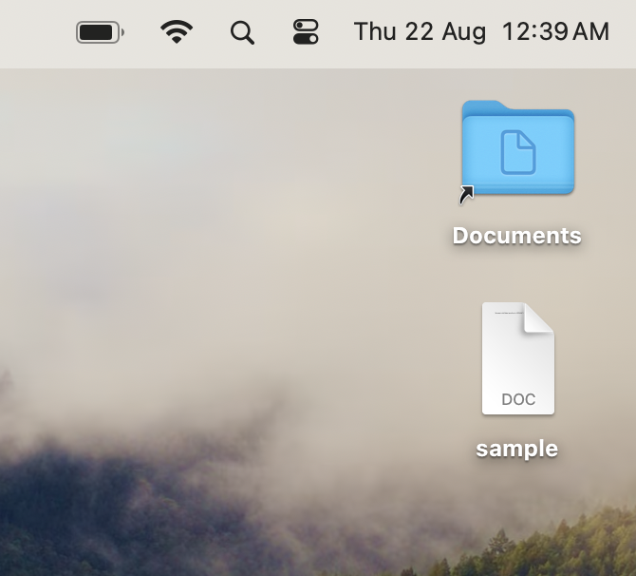

c. FIFO

**juhirajani@Juhis-Laptop ~ %** mkfifo /Users/juhirajani/Documents/fifofile

**juhirajani@Juhis-Laptop documents %** ls -l /Users/juhirajani/Documents/fifofile

Output -

prw-r--r--@ 1 juhirajani staff 0 Aug 22 00:50 /Users/juhirajani/Documents/fifofile